Case 3-Asia-Indus-Mohenjo Daro-Female-Figurine-Abstract Plinth-2500-2000-BCE

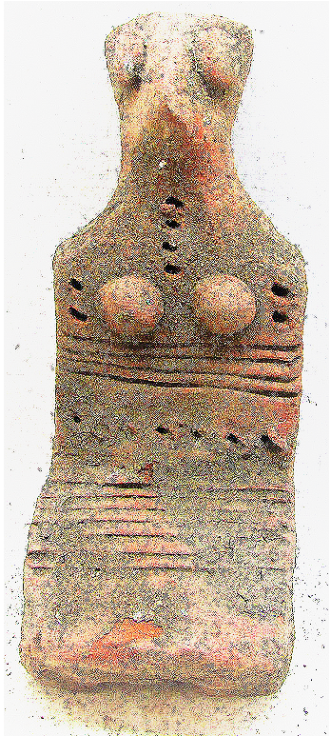 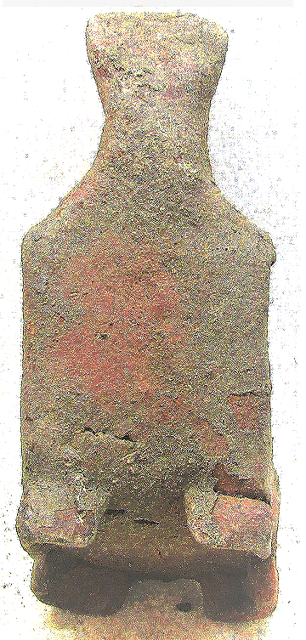

Figs. 1-2. Asia-Indus-Mohenjo Daro-Female-Figurine-Abstract Plinth-2500-2000-BCE

**Case no.: 3**

**Accession Number:**

**Formal Label:** Asia-Indus-Mohenjo Daro-Female-Figurine-Abstract Plinth-2500-2000-BCE

**Display Description:**

**This early abstract female figurine in the form of a plinth or terra cotta slab has symbolic decorations that are suggestive of eyes and breasts, four punctations for a necklace, two punctations on either side of the breasts as a covering, four horizontal lines underneath of the breasts as a covering, seven punctations below these horizontal lines as the end of a covering, seven horizontal lines in the torso area as a covering, perhaps a skirt or kilt. The figure was meant to stand upright on four blocks on its bottom. As such it probably represented a goddess.**

**LC Classification:**

**Date or Time Horizon:**

**Geographical Area:**

**Map:**

**GPS coordinates:**

**Cultural Affiliation:**

**Media:**

**Dimensions:**

**Weight:**

**Condition:**

**Provenance:**

**Discussion:**

**References:**